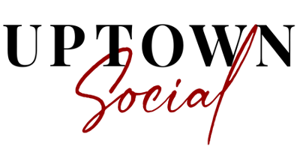

Safety Guidelines for Upcoming Shows

Our shows will be presented under the guidelines issued by the State of Indiana and the LaPorte County Health Department. During this time, the health and safety of our guests and team members is the leading priority. We have a dedicated team focused on staying up-to-date on CDC recommendations and government guidelines.
The following precautions are being observed for the safety of our customers, artists and staff:
- The LaPorte County Health Department is strongly encouraging all guests, whether vaccinated or not, to wear masks within all buildings. Face coverings will be available at our main entrance, if needed.
- Touchless hand sanitizing stations are provided in the venue.
- Washrooms are equipped with touchless soap dispensers, faucets and hand dryers.
- Points of contact are rigorously monitored and sanitized by staff
- The Venue will be thoroughly cleaned and sanitized before and after each performance.

- We believe that health and safety is a shared responsibility and ask that all guests follow recommendations from the CDC and do not attend a show if you have a fever, cough, or respiratory symptoms, or have recently been in contact with someone who was sick.

- While we have taken enhanced safety measures, an inherent risk of exposure to COVID-19 exists in any public place. The CDC advises that senior citizens and those with underlying health conditions are especially vulnerable. By visiting Uptown Social, you voluntarily assume all risk related to exposure of COVID-19.

We remain more committed than ever to creating the safe, fun atmosphere that is essential to the Uptown Social event experience!

